After deploying backstage in kubernetes cluster, peform the following steps:

create a sample application and deploy it in kubernetes cluster
I copied the sample application from this location to my local folder.
- https://github.com/guymenahem/how-to-devops-tools/blob/main/backstage/exmaple-application/example-app.yaml
- https://github.com/guymenahem/how-to-devops-tools/blob/main/backstage/exmaple-application/user-api-component.yaml

These files (sample files) or our own sample files can be copied to our github repo and with access key it will allow the registration of user-api-component.yaml file from backstage UI
if connecting directly , the component can be registered from UI.
In case of unauthorized error it is required to configure the access key in backstage secrets yaml file and redeploy.
if github access key is already configured no need to redeploy in kubernetes.

executed the command to deploy the sample application from local
kubectl apply -f example-app

After this step redirect the requests to the port if required (sample command)
sudo kubectl port-forward --namespace=backstage svc/backstage 80:80

F In the next step the user component can be registered from UI

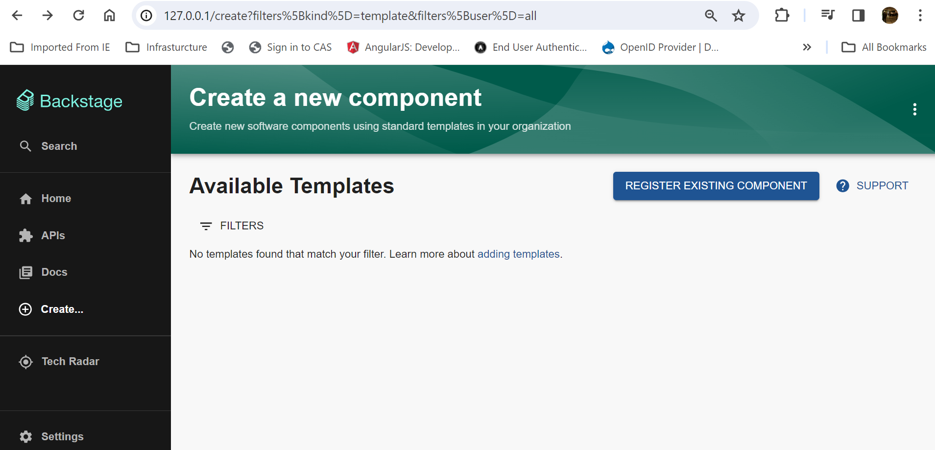
on clicking REGISTER EXISTING COMPONENT button it will open the import screen

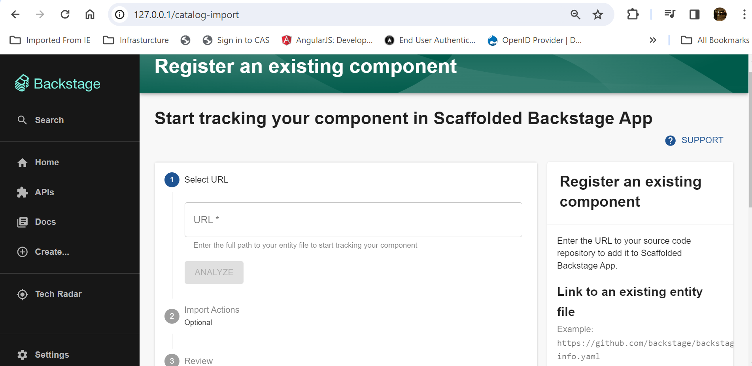

I have used the below url in the url box and click on analyze will allow you to import

https://github.com/guymenahem/how-to-devops-tools/blob/main/backstage/exmaple-application/user-api-component.yaml

Once it is imported the home page will show the catalog where the user api is listed.

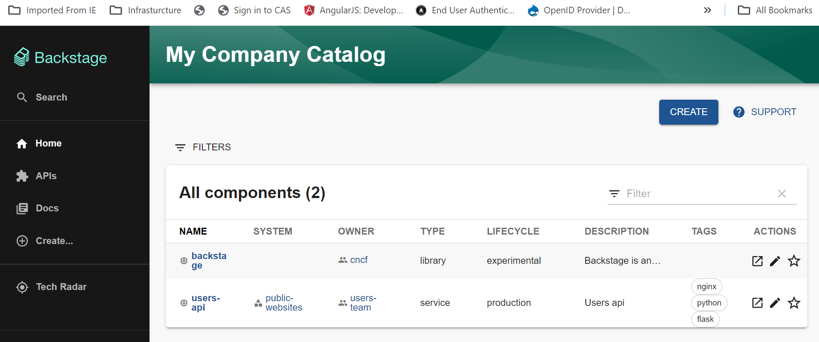
On clicking the users-api link it will open the detail page, where the kubernetes tab is visible

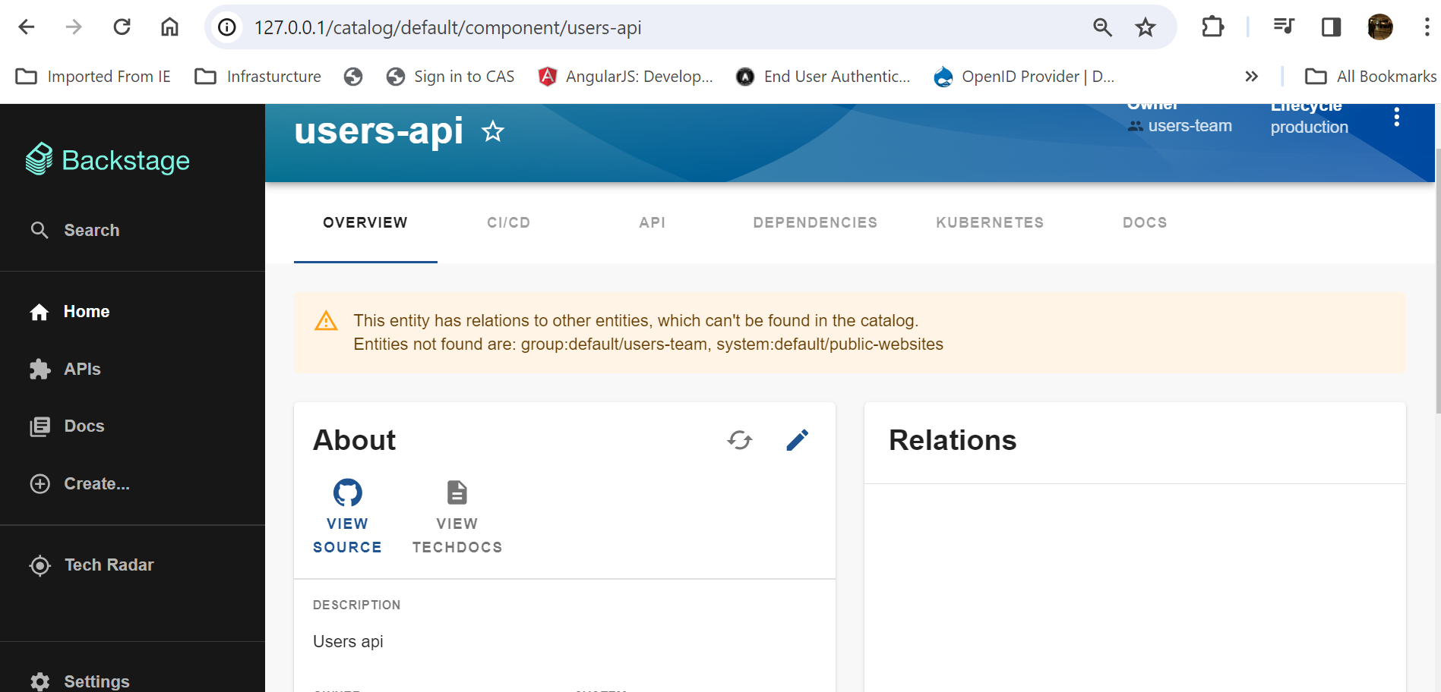
Selecting kubernets tab shows the screen with pod details.

